

## MAJOR PROJECT REPORT

## ON BLOOD BANK MANAGEMENT SYSTEM

## SUBMITTED TO:- SUBMITTED BY:-

Mrs Rohika Bhatt PragatiThakur(130610304026)

PriyadarshniSharma(130610304030) Neha Thakur(150620304003)

Pushpa(150620304004)



**CERTIFICATE**

We hereby certify that the work which is being presented in the diploma major project report titled **“Blood Bank Management System”,** in partial fulfillment of the requirements for the award of the Diploma in Computer engineering and submitted to the department of Computer Engineering of Government Polytechnic for Women Kandaghat (H.P) is an authentic admission record of our own work carried out under the supervision of **Mr. Pankaj** **Pathik** , H.O.D of Computer Engineering Department.

The matter presented in this report has not been submitted by me for the award of any other diploma elsewhere.

## Pragati Thakur(130610304026)

## PriyadarshniSharma(130610304030)

## Neha Thakur(150620304003)

## Pushpa(150620304004)

## This is to certify that the above statement made by the candidate is correct to the best of my knowledge.

## HOD Computer Engineering: Project Guide:

## Mr. Pankaj Pathik Mrs. Rohika Bhatt

## Principal of GPW Kandaghat HP

## Dr. P.P Sharma

## ACKNOWLEDGEMENT

We express our deep sense of gratitude towards our project guide who has in various ways helped in the successful completion of this project . We would like to express our gratitude to Mrs.Rohika Bhatt for his genuine interest and supplying us the right motivation and environment to work in.

We are also thankful to our respected Principal Sir. All facality members who helped us to complete this project.

## 

## 

## CONTENTS

## Topic Page no

1. INTRODUCTION

1.1 Objective

1.2 Hardware Requirement

1.3 Software Requirement

1.4 Working

1.5 Benefits

1.6 Future Scope

2

9**.** CONCLUSION

10.BIBLIOGRAPHY

## INTRODUCTION

The main aim of this project blood bank management system is to maintaining all the information pertaining to blood donors, different blood groups available in each blood bank and helps them manage in a best way. This system provides transparency in this field, make the process of obtaining blood from a blood bank corruption free and make the system of blood bank management effective. The project consists of central repository containing various blood groups deposit available along with related details.

These details include blood type, storage area and date of storage. These details help in maintaining the blood deposits. The project is an online system that allows checking whether required blood deposits of a particular group are available in the blood bank. This system also help to keep record of patient name and contacts, blood booking and even need for certain blood group is posted on the website to find available donors for a blood emergency.

This system is developed on php platform and supported by a MySQL database to store blood and user specific details. Blood bank management system provides the donors information system, acceptor information system, staff information system. Donor information system details with the organization of the voluntary data.

**OBJECTIVE OF PROJECT**

The main objective of this application is to automate the complete operations of the blood bank. They need maintain hundreds of thousands of records. Also should be very faster so the can find required details instantly.

**Software specification:-**

* Technology implemented:- Apache server.
* Language used :- PHP, HTML
* Database:- MYSQL.
* User interface design: HTML, JAVASCRIPT.
* Web browser: Mozilla, Google chrome, Internet explorer.

**Hardware requirements:-**

* Processor : Pentium, AMD or higher version
* Operating system:- window7/window 8/window 10.
* Ram: 256MB, 2GB recommended.
* Hardware devices: keyboard with mouse.
* Hard Disk: 10GB or more.

**Requirement and Technical Specifications**

**Organizations usually face problems or have opportunity due to the following:**

* a new product or plant or branch
* a new market or new process
* inefficiency of an existing system
* Structural error in the existing system, etc.

**For identifying problems/opportunities, we scan the following:**

* is the performance of the system
* the information being supplied and its form
* the economy of processing
* the control of the information processing
* the efficiency of the existing system
* the security of the data and software
* the security of the equipment and personnel, etc.

After identificationof the problem, it is defined and a general direction or method for solving this problem is also determined. Then project boundaries are defined. The management establishes the term of reference as well as the resources to be provided for the project. System development is an iterative process and the first identifiable stage of it Problem Definition, whose final output is Terms of Reference.

**About Server**

We uses the Xampp server for running project. It stands for Cross Platform Apache MySQL, PHP, Perl. It is an most popular PHP development environment. Xampp is a completely free, easy to install Apache distribution containing MariaDB, PHP and Perl.

**X :** any of the different operating systems (Window, Linux, Mac OS X), to be read as “cross”, meaning cross-platform.

**A :** Apache (HTTP Server)

**M :** MySQL(Database)

**P :** PHP

**P :** Perl

**Snapshot of XAMPP are:-**

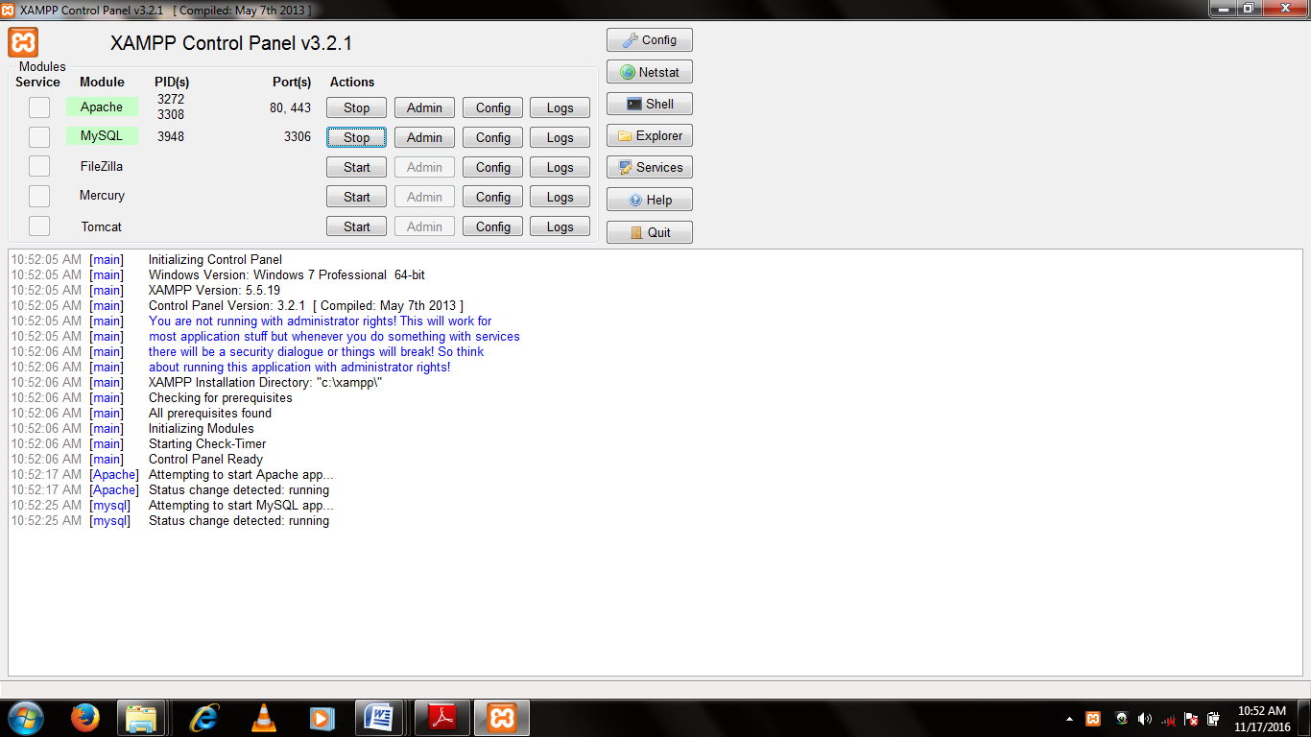

**IMPORTANT FEACTURE OF XAMPP**

* It is a simple, lightweight Apache distribution that makes it extremely easy for developers to create a local web server for testing purposes.
* Everything you need to set up a web server – server application (Apache), database (MySQL), and scripting language (PHP) – is included in a simple e
* xtractable file.
* XAMPP is also cross-platform, which means it works equally well on Linux, Mac and Windows.
* Since most actual web server deployments use the same components as XAMPP, it makes transitioning from a local test server to a live server is extremely easy as well.
* XAMPP is regularly updated to incorporate the latest releases of Apache, MySQL, PHP and Perl.

* It also comes with a number of other modules including Open SSL, phpMyAdmin, Media Wiki, Joomla, WordPress and more.
* Self contained, multiple instances of XAMPP can exist on a single computer, and any given instance can be copied from one computer to another. XAMPP is offered in both a full and a standard version.

**INTROUCTION TO HTML**

**Html** is a hyper text markup language it is used to create Web pages.

* HTML stands for Hyper Text Markup Language
* A markup language is a set of markup tags
* HTML documents are described by HTML tags
* Each HTML tag **describes** different document content

**Structure of HTML**

<!DOCTYPE html>

<html>

<head>

<title> xyz </title>

</head>

<body>

Body of the letter.

</body>

</html>

* The **<!DOCTYPE html>** declaration defines this document to be HTML5
* The text between **<html>** and **</html>** describes an HTML document
* The text between **<head>** and **</head>** provides information about the document
* The text between **<title>** and **</title>** provides a title for the document
* The text between **<body>** and **</body>** describes the visible page content
* The text between **<h1>** and **</h1>** describes a heading
* The text between **<p>** and **</p>** describes a paragraph

## Html Elements

## 1) Paired Tag

## 2) Unpaired Tag

## Paired Tags

## <HTML>

## <HEAD>

## <TITLE>

## <BODY>

## <FONT>

## LIST Element

## Heading Element

## Unpaired Tags

## Horizontal tag(<HR>)

## Break Tag(<BR>)

## Heading tags:-

<h1>my first heading</h1> Close tag by forward slash.

## C:\Users\Master\Pictures\report\h1.png

## HTML Formatting Elements

In the previous chapter, you learned about the HTML **style attribute**.

HTML also defines special **elements** for defining text with a special **meaning**.

HTML uses elements like <b> and <i> for formatting output, like **bold** or *italic* text.

Formatting elements were designed to display special types of text:

## <b> - Bold text e.g. xyz

## <i> - Italic text e.g. *xyz*

## <small> - Small text e.g. xyz

## <big>-Big text e.g. xyz

## <sub> - Subscript text e.g. H2O

## <sup> - Superscript text e.g. Ca2+

## HTML table Element

An HTML table is defined with the **<table>** tag. Each table row is defined with the **<tr>** tag. A table header is defined with the **<th>** tag.

By default, table headings are bold and centered. A table data/cell is defined with the **<td>** tag.

## C:\Users\Master\Pictures\report\TABLE.png

## HTML form Element

HTML forms are used to collect user input.

The **<form>** element defines an HTML form:

**<input type="text">** defines a one-line input field for **text input**:

**<input type="radio">** defines a **radio button**.

**<input type="submit">** defines a button for **submitting** a form to a **form-handler**.

The form-handler is typically a server page with a script for processing input data.

The **<select>** element defines a **drop-down**

The **<option>** elements defines the options to select.

The list will normally show the first item as selected.

The **<text area>** element defines a multi-line input field (**a text area**)

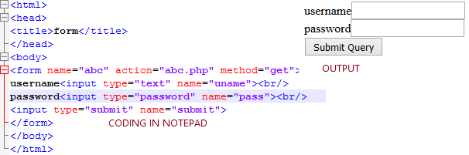

**INTRODUCTION TO PHP**

PHP is a server scripting language, and a powerful tool for making dynamic and interactive Web pages.

PHP is a widely-used, free, and efficient alternative to competitors such as Microsoft's ASP.

PHP (recursive acronym for *PHP: Hypertext Preprocessor*) is a widely-used open source general-purpose scripting language that is especially suited for web development and can be embedded into HTML.

You can even configure your web server to process all your HTML files with PHP, and then there's really no way that users can tell what you have up your sleeve.

**What is PHP:-**

* PHP is an acronym for "PHP: Hypertext Preprocessor"
* PHP is a widely-used, open source scripting language
* PHP scripts are executed on the server
* PHP is free to download and use

**Why PHP?**

* PHP runs on various platforms (Windows, Linux, Unix, Mac OS X, etc.)
* PHP is compatible with almost all servers used today (Apache, IIS, etc.)
* PHP supports a wide range of databases
* PHP is free. Download it from the official PHP resource: [www.php.net](http://www.php.net/)
* PHP is easy to learn and runs efficiently on the server side

**What Can PHP Do?**

* PHP can generate dynamic page content
* PHP can create, open, read, write, delete, and close files on the server
* PHP can collect form data
* PHP can send and receive cookies
* PHP can add, delete, modify data in your database
* PHP can be used to control user-access
* PHP can encrypt data

**VARIABLE IN PHP**

* Php is the location of computer memory where we can be store the data and get data.

Rules of PHP variable:-

* A variable starts with the $ sign, followed by the name of the variable
* A variable name must start with a letter or the underscore character
* A variable name cannot start with a number
* A variable name can only contain alpha-numeric characters and underscores (A-z, 0-9, and _ )
* Variable names are case-sensitive ($age and $AGE are two different variables)

**Data type in PHP :-**

* Variables can store data of different types, and different data types can do different things.
* **PHP supports the following data types:**
* String
* Integer
* Float (floating point numbers - also called double)
* Boolean
* Array
* Object
* NULL
* Resource

**OPERATOR**

Operators are used to perform operations on variables and values.

**PHP divides the operators in the following groups:**

**Arithmetic operators:-**

The PHP arithmetic operators are used with numeric values to perform common arithmetical operations, such as addition, subtraction, multiplication etc.

**Assignment operators:-**

The PHP assignment operators are used with numeric values to write a value to a variable.

**Comparison operators:-**

The PHP comparison operators are used to compare two value.

**Increment/Decrement operators:-**

The PHP increment operators are used to increment a variable's value.The PHP decrement operators are used to decrement a variable's value.

**PHP form Handling**

One of the most powerful features of PHP is the way it handles HTML forms. The basic concept that is important to understand is that any form element will automatically be available to your PHP scripts. Please read the manual section on [Variables from external sources](http://php.net/manual/en/language.variables.external.php) for more information and examples on using forms with PHP. Here is an example HTML form:

<form action="action.php" method="post">

<p>your name: <input type="text" name="name" /></p>

<p>Your age: <input type="text" name="age" /></p>

<p><input type="submit" /></p>

</form>

**CSS**

**CSS** stands for **C**ascading **S**tyle **S**heets. CSS describes how HTML elements are to bedisplayed on screen, paper, or in other media.CSS saves a lot of work. It can control the layout of multiple web pages all at once.

**CSS can be added to HTML elements in 3 ways:**

* **Inline** - by using the style attribute in HTML elements
* **Internal** - by using a <style> element in the <head> section
* **External** - by using an external CSS file

## Inline CSS

An inline CSS is used to apply a unique style to a single HTML element. An inline CSS uses the style attribute of an HTML element.

**Syntax:-**

<p style=“color:red;font-size:18px”> abc</p>

**Internal CSS**

An internal CSS is used to apply a style to a single HTML page. We can add this CSS along the <HEAD > section.

**Syntax:-**

<head><style type=“text/css”>

h1{color:blue:}

p{color:green:}</style></head>

## External CSS

An external style sheet is used to define the style for many HTML pages. With an external style sheet, you can change the look of an entire web site, by changing one file!

**Syntax of css:-**

Selector

{

Property: value;

}

**Example with snapshot:-**

The following are the snapshot of the external CSS. In this snapshot, we have two files, one is the CSS file and other is the HTML file. We link the CSS file with HTML page through the above syntax. And the output will be given below with small snapshot.

**This is the navigation bar of my project:-**

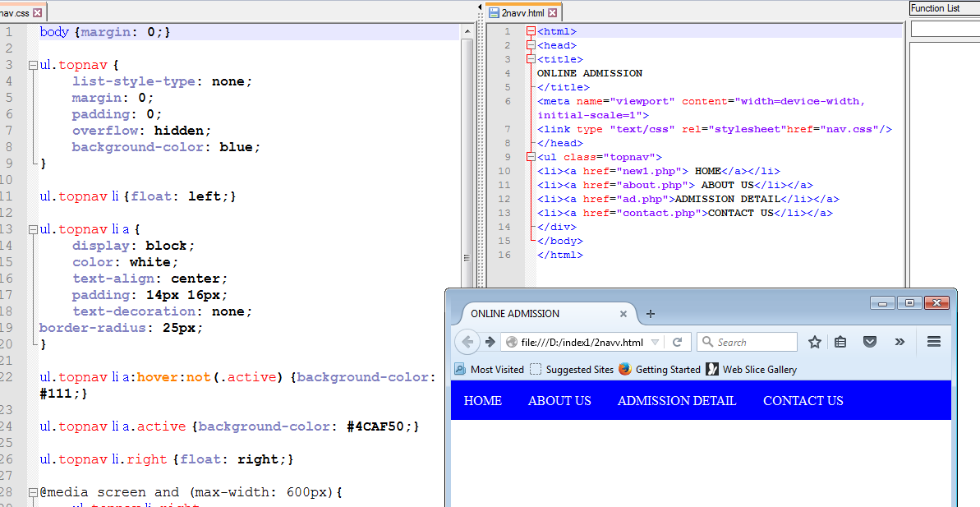

**JAVA SCRIPT**

**The HTML <script> Tag:-**

The **<script>** tag is used to define a client-side script (JavaScript).

The <script> element either contains scripting statements, or it points to an external script file through the **src** attribute. Common uses for JavaScript are image manipulation, form validation, and dynamic changes of content.

**The HTML <noscript> Tag:-**

The **<noscript>** tag is used to provide an alternate content for users that have disabled scripts in their browser or have a browser that doesn't support client-side scripts:

**JavaScript Operators**

## JavaScript Arithmetic Operators

Arithmetic operators are used to perform arithmetic on numbers (literals or variables).

|  |  |
| --- | --- |
| * + | Addition |
| * - | Subtraction |
| * * | Multiplication |
| * / | Division |
| * % | Modulus |
| * ++ | Increment |
| * -- | Decrement |

## JavaScript Assignment Operators

|  |  |  |
| --- | --- | --- |
| * = | x = y | x = y |
| * += | x += y | x = x + y |
| * -= | x -= y | x = x – y |
| * *= | x *= y | x = x * y |
| * /= | x /= y | x = x / y |
| * %= | x %= y | x = x % y |

## JavaScript Comparison and Logical Operators

|  |  |
| --- | --- |
| * == | equal to |
| * === | equal value and equal type |
| * != | not equal |
| * !== | not equal value or not equal type |
| * > | greater than |
| * < | less than |
| * >= | greater than or equal to |
| * <= | less than or equal to |
| * ? | ternary operator |

A JavaScript function is a block of code designed to perform a particular task.

A JavaScript function is executed when "something" invokes it (calls it).

**JavaScript Function Syntax**

A JavaScript function is defined with the **function** keyword, followed by a **name**, followed by parentheses **()**.

Function names can contain letters, digits, underscores, and dollar signs (same rules as variables).

The parentheses may include parameter names separated by commas:  
**(parameter1, parameter2, ...)**

The code to be executed, by the function, is placed inside curly brackets: **{}**

Function function_name(parameter1 parameter3)

{

Code to be executed.

}

**Using JavaScript on Web Page**

We do the use of JavaScript on our project for making our project or web site dynamic.

There are different pages where we use the JavaScript.

**Following are the snapshot of the web page where we use the JavaScript :-**

Coding Output

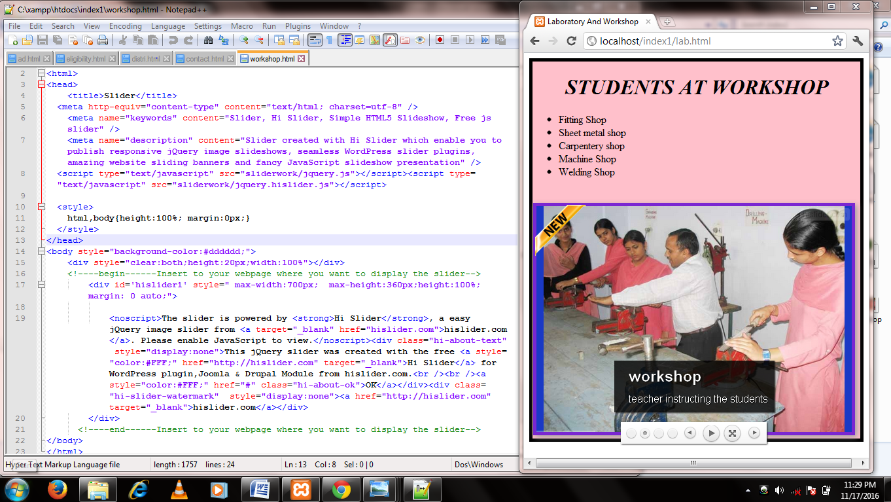

The <script> element either contains scripting statements, or it points to an external script file through the **src** attribute. Common uses for JavaScript are image manipulation, form validation, and dynamic changes of content.

**MY SQL**

* MySQL is a database system used on the web
* MySQL is a database system that runs on a server
* MySQL is ideal for both small and large applications
* MySQL is very fast, reliable, and easy to use
* MySQL uses standard SQL
* MySQL compiles on a number of platforms
* MySQL is free to download and use
* MySQL is developed, distributed, and supported by Oracle Corporation

The data in a MySQL database are stored in tables. A table is a collection of related data, and it consists of columns and rows.

**Queries:-**SQL is used to communicate with a database. According to ANSI (American National Standards Institute), it is the standard language for relational database management systems. SQL statements are used to perform tasks such as update data on a database, or retrieve data from a database.

**The CREATE TABLE statement is used to create a table in MySQL.Create database:-**

**Syntax: -**

CREATE TABLE MyGuests (  
id INT(6) UNSIGNED AUTO_INCREMENT PRIMARY KEY,  
firstname VARCHAR(30) NOT NULL,  
lastname VARCHAR(30) NOT NULL,  
email VARCHAR(50),  
reg_date TIMESTAMP  
);

**Insert Values:-**

After a database and a table have been created, we can start adding data in them.

**Syntax:-**

INSERT INTO table_name (column1, column2, column3,...)  
VALUES (value1, value2, value3,...)

**Delete Values:-**

The DELETE statement is used to delete records from a table:

**Syntax: -**

DELETE FROM table_name  
WHERE some_column = some_value

## ALTER TABLE Statement

The ALTER TABLE statement is used to add, delete, or modify columns in an existing table.

**Add columns:-**

**Syntax:-**

ALTER TABLE table_name  
ADD columnname datatype

**DELETE TABLE:-**

To delete a column in a table, use the following syntax (notice that some database systems don't allow deleting a column):

ALTER TABLE table_name   
DROP COLUMN column_name

## The SQL SELECT Statement

The SELECT statement is used to select data from a database.

The result is stored in a result table, called the result-set.

**SQL SELECT Syntax:-**

SELECT *column_name*,*column_name*  
FROM *table_name*;

and

SELECT * FROM *table_name*;

**CREATING A DATABASE**

Now creating the database in MySQL . For this we follow the following steps:-

* Firstly we open the Xampp Server.
* Then start the Apache.
* And also start the MySQL.
* After that go to MySQL Admin.
* Then the following type of window will be open and we create the database.

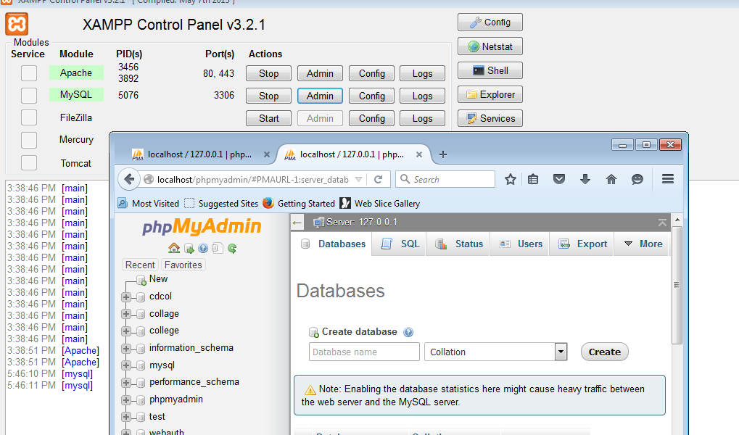

We enter the database name “**college**” and click on **Create** option.

* Now we create a **“student”** table inside the **college** database. And create different fields inside the table. We have four fields rollno., name, dob, contactno.

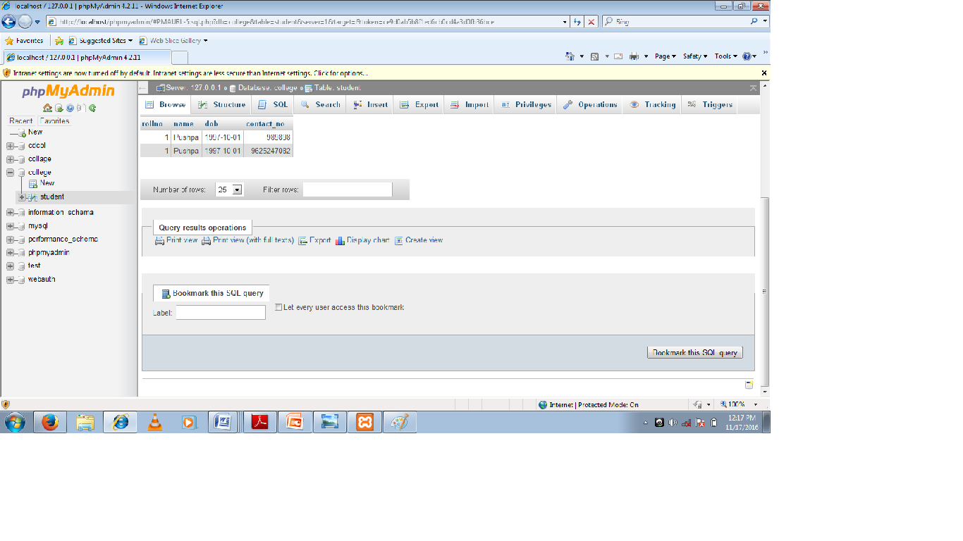

Table:-It is a combination of rows and columns. It means when we combine the two or more than two rows and columns, then we find and make a **table.**

**SNAPSHOT OF THE ADMISSION FORM:-**

The following are the admission form, and student fill this form by putting the all detail

which are required.

Code in notepad++ Output

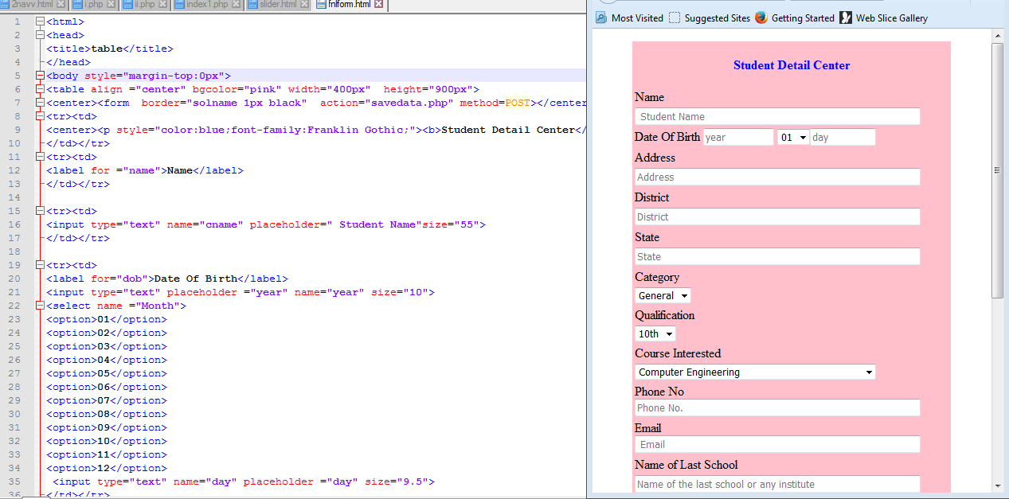

We write continue this code and fill all the blocks and click on “**submit”** option

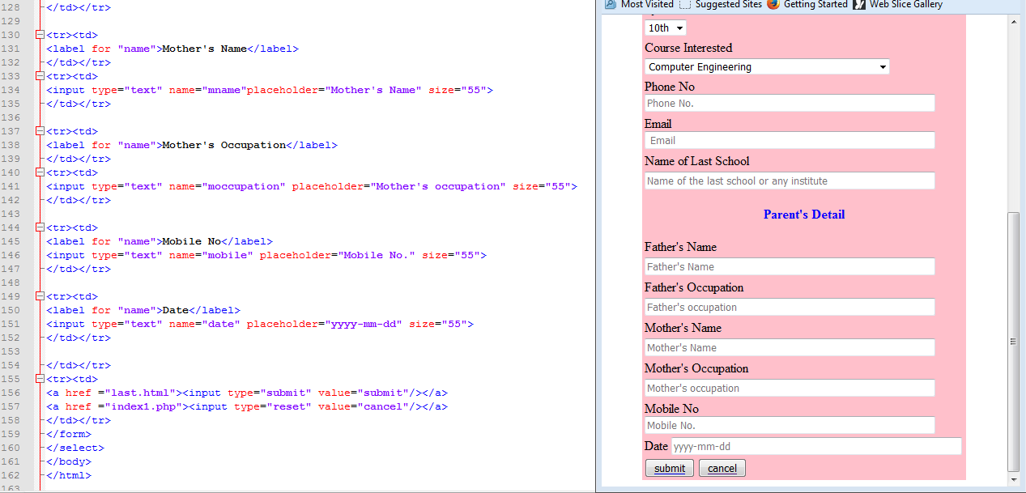

When we submit the student detail then the student data will be save on the back end (MySQL).

**Handling database with php**

A database is used to store data .A relational database stores data in tables there are linked with common field, known as a key.

## Connecting to a database :-

A website connect to a database to access and store information. A connection is established with the help of a data source name. A data source name is a structure containing information required to connect to the database.

Php and my sql server are automatically installed while constomizing the installation of Linux operating system.

**The syntax to connect to the My sql Server is as follow:-**

$link_id=mysql_connect(“hostname”,”user_name”,”password”);

**Hostname :-** specifies the name of the server on which the database is running. The default location of My SQL server is localhost**.**

**User_name:-** specifies the username.

**Password:-** specifies the password to connect to the database. This is an optional argument because a user account can be created without a password.

**$_link_id**:- Store the return value of the connection. The variable determines whether the connection is establishment or not.

**Mysq_list_dbs():-** function display all the database variable on the server.

Syntax:-

mysql_list_dbs($link_id);

**Mysql_select_db():-** The function defines the databases that will be used for the connection.

**Syntax:-**

mysql_list_db(“”database name”,$link_id);

**mysql_list_tables():-** this function display a list of all the table available in the Specified database.

**Syntax:-**

mysql_list_tables(“database_name”,$link_id);

**mysql_close():-** close the mysql_close() function.

**Syntax:-**

mysql_close($link_id);

The following are the snapshot of the coding which connect the front end to back end:-

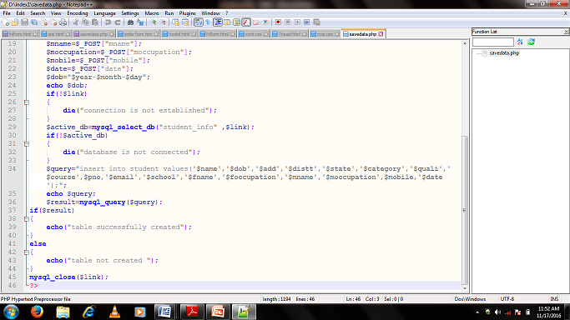

**SNAPSHOTS OF PROJECT**

This is the front view (Home page) of my project.

Coding Output

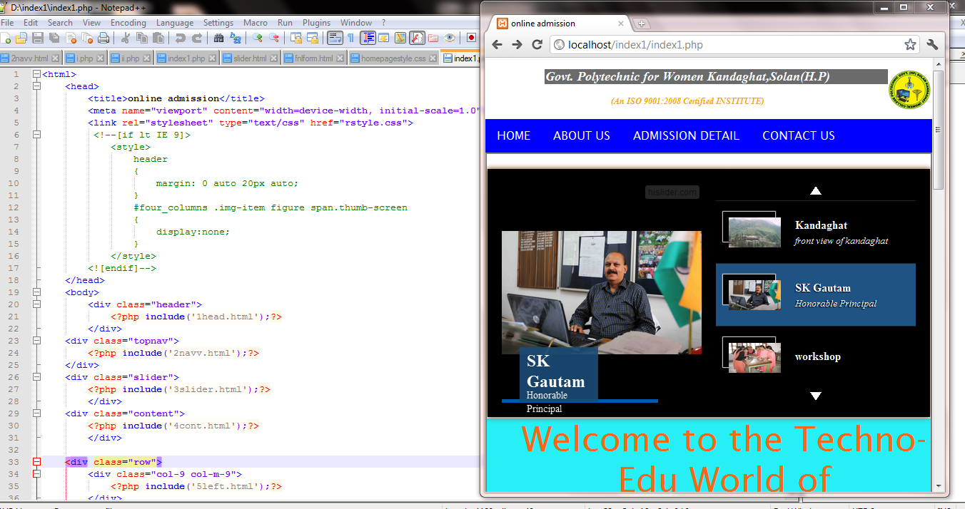

In this project, we make a online admission form for our college. Any student can take admission in the time period of admission.

In above page is the main and front page of my web site. All the pages are linked to this page.

This is the “HOME” page of my web site. There are many information to admission regarding on this web site.

* **About us** is the second page of my project. Its view are as following:-

Code Output

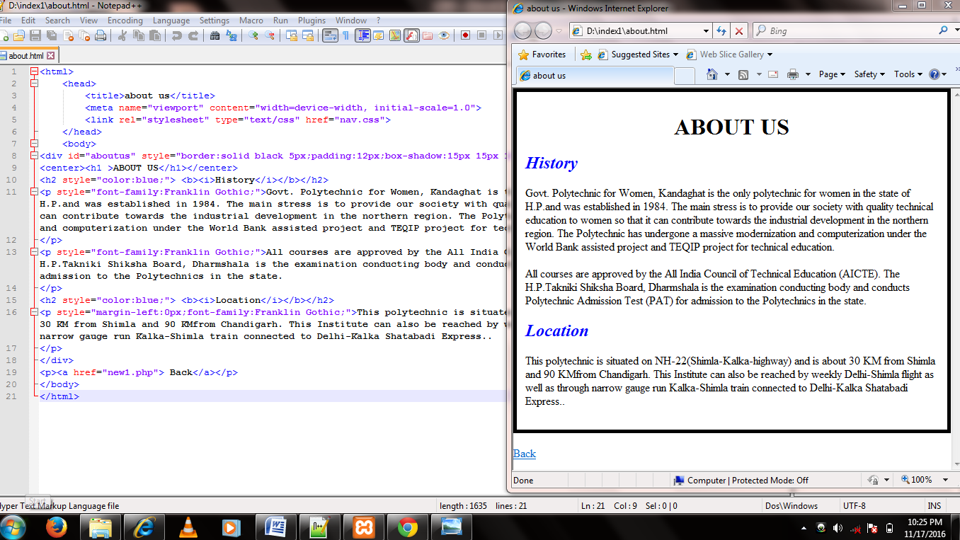

We uses the different HTML tags for creating a web page. If we save the page .html extension then the page is an HTML page

If we save an page with .php extension then the saved page is PHP page.

The main difference between these pages is that the HTML page runs on any browser. We does not need any server for running it.

But on the other hand, PHP also runs on browser with the help of any server which we use.

**Admission Detail** is the next page of my project. In this page, we are linked different page. These pages have the all information about admission.

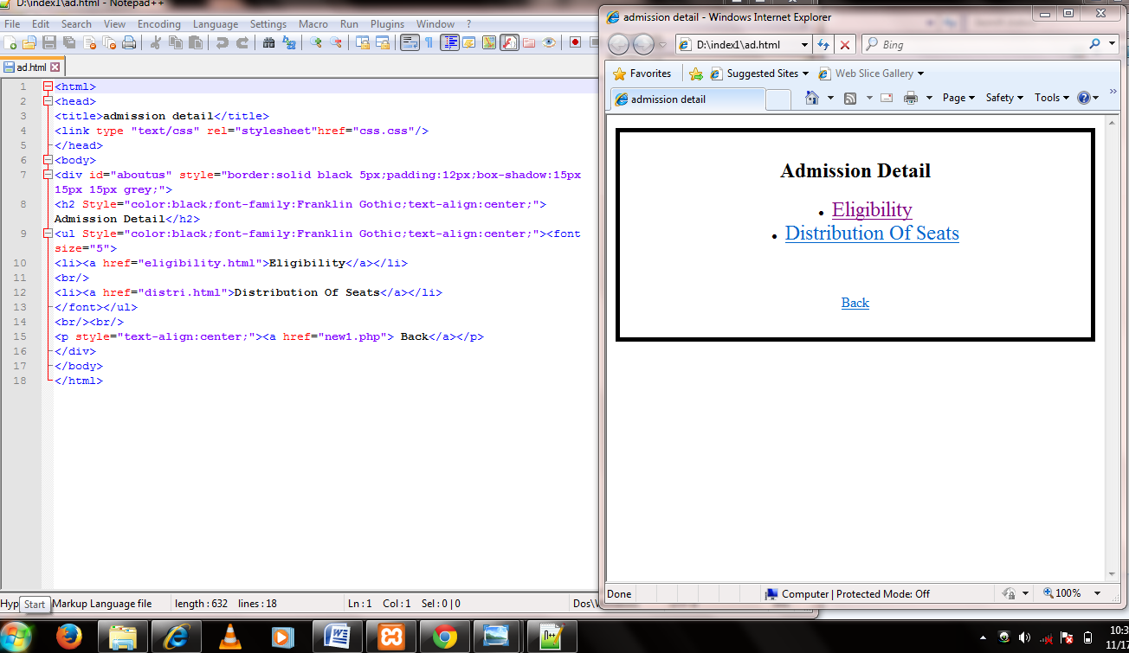

In this page, we linked the two pages: **Eligibility** and **Dist ribution of seats.**

When we click on **Eligibility**, followingsnapshot are for this:-

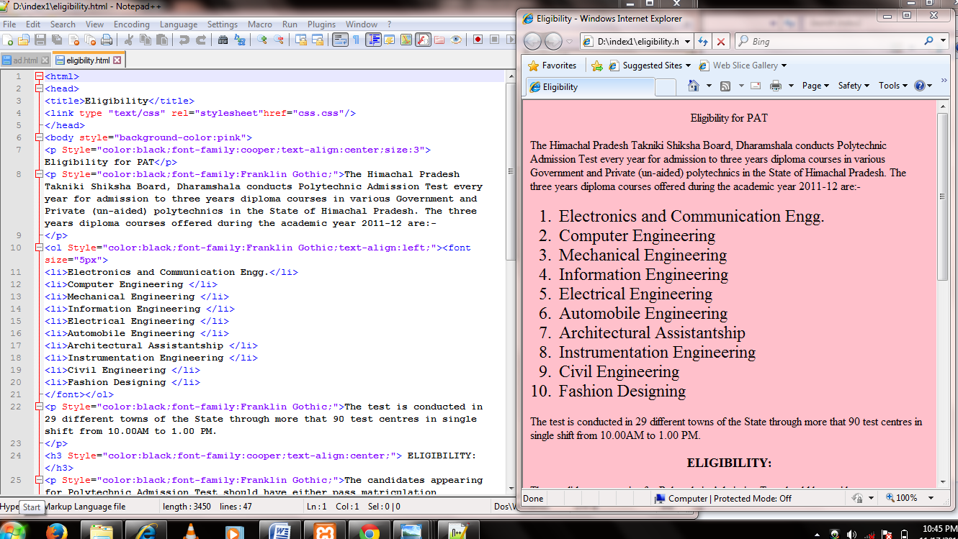

And when we click on **Distribution of seats** following snapshotdisplay**:-**

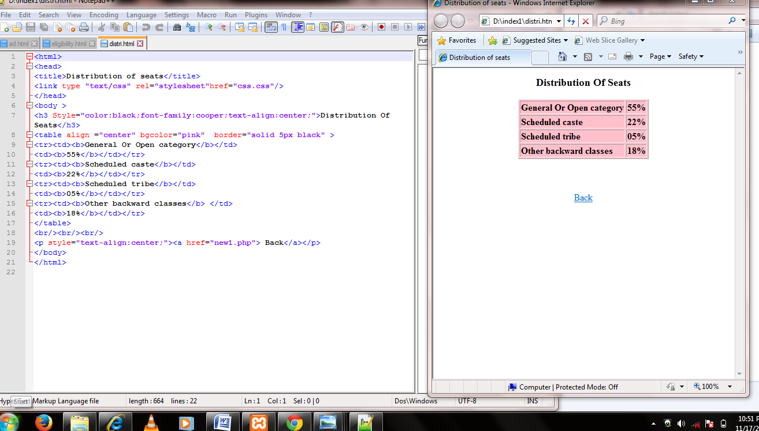

The next snapshot is for **contact us.** In this page, student can get help by calling the helpline no which are given on the project.

Coding Output

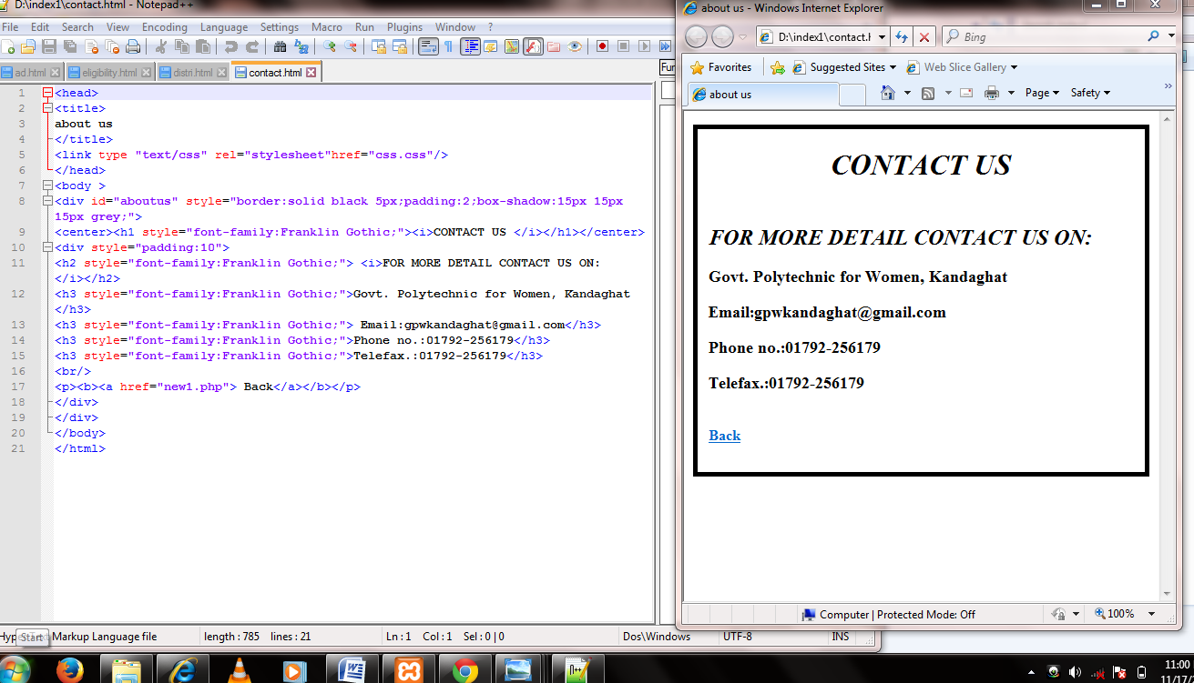

There are some other pages in my project. These have some other information like hostel related, library, laboratories and workshops.

The most important is the “**apply online**” option. This is the main part of my project because the project is online admission form. Therefore when we click on “**apply online”** then the form is displayed which we already discuss about above.

The following is the snapshot:-



The institute have its own co-operative mess for all the hostels which is maintained and organized by girls students under the guidance of hostel encharge.

Every student has to deposit her mess bill till 10th of every month. The Day Scholars are also allowed to take their lunch in hostel mess subject to the prior information.

**SCOPE OF FUTURE APPLICATION**

This project can be used in any Online Admission site after adding some more useful modules in the project for which retailer are providing services.

Utmost care and back up procedures must be established to ensure 100% successful implementation of the computerized billing system. In case of system failure, the organization should be in a position to process the transaction with another organization or if the worst comes to the worst, it should be in a position to complete it manually.

## 7.CONCLUSION

In this report we learned a computer language PHP. Before learn PHP, we It has been developed in HTML, CSS, PHP and MySQL keeping in mind the specifications of the system.

For designing the system we have used simple data flow diagrams.

Overall the project teaches us the essential skills like:

* Using system analysis and design techniques like data flow diagrams in designing the system.
* Understanding the database handling and query processing.

## 8.Bibliography

## [www.w3schools.com](http://www.w3schools.com)

## [www.google.com](http://www.google.com)